Data 205

Professor Linehan

Abraham Lewis

Capstone Report

County Permits

Before work is commenced at any job site in Montgomery County- or for that matter anywhere the potential of bureaucracy has been actualized- the work must first go through the process of being approved by the County. This process of approval normally comes in the form of a permit, which the Department of Permitting Services issues upon there receiving of said permit. These permits can literally be issued on anything. The next step after they have been issued is to hopefully continue with the work and complete it. The final step is to have an inspector come down and “final” the permit.

This report will show the findings in of my investigation into the permits from 2 data sets from data Montgomery, which cover both residential permits and commercial permits throughout the County from the years 2000 to 2019.

Some of the questions this report sets out to answer:

1. What do most “issued” permits consist of?
2. Are there area’s in the County which get more permits issued, and appended to that, what were the type of permits.
3. Are variables such as value, area linked in any way?
4. Does a permits work type generally show what valuation of permit will be?
5. Are there general trends in areas such as housing or solar panels that can be shown from these data sets?
6. Does the Counties reported average of hold up in the data set?

An over of the data sets shows that they both contain the same 20 columns and the commercial data set contains 28806 rows while the residential contains138715.

The 20 columns are as follows:

1.Permit Number assigned to uniquely identify permit

2.Status of permit; if a permit is open, stop work etc.

3. Street number of work location

4.Pre-direction if the street name has a direction as a prefix. For example, E Jefferson St

5.Street Name of work location

6.Street Suffix such as ST, PL, RD

7.Post-direction; if the street name has a direction after the name. For example, University Blvd W (Where I live.)

8.City of work location

9.State of work location

10.Zip Code of work location

11.Added Date; The date that the applicant applied for the permit and the information was entered into the database

12. Issue Date; The date that the permit is issued. When the permit is issued, construction is allowed to commence. DPS has reviewed the construction plans according to the applicable building and life safety codes and approved the plans

13.Date & Time Final Date; The final date indicates the date that construction has been completed and approved by DPS. The final inspection was conducted that date/time by the DPS inspector and was acceptable

14.Building Area; The number of square feet for the proposed construction. For a new home, it is the entire building area. For an addition or alteration, it represents only the area of the affected space, not the entire structure

15.Declared Valuation; The value or cost of the proposed construction or work as declared by the applicant

16. Description of planned work

17.Application Type; Type of permit application

18.Work Type; Type of work to be performed

19.Use Code; Type of structure work will be performed on

20.Location; a string containing all the address data plus latitude and longitude coordinates.

(Source*;* [*https://data.montgomerycountymd.gov/Licenses-Permits/Commercial-Permits/i26v-w6bd*](https://data.montgomerycountymd.gov/Licenses-Permits/Commercial-Permits/i26v-w6bd))

The listed columns fall into three categories:

1.Location Data

2.Status

3.Description

Before conducting exploratory analysis on the data sets there was a need to first organize and clean the data. Both the commercial and residential data sets were fairly clean with only about 2000 rows having to be dropped. One of the things that was checked was if the Status columns with the date information matched with the Status column.

In terms of wrangling the useless columns such as state were dropped and in the commercial and residential index was reset to match when the permits were added so that the data would be chronological. The goal with the wrangling was to make the data set more conducive to telling a story. To that affect some new columns were induced, such as column for the Lat and Long data. Other columns were induced by making buckets out of the the numerical variables such as ‘Value’ and “Area’. One thing that was very interesting, was getting the cities to map to their proper zip code. Doing this truly showed the power of iterating in Python. Finally, basic things like changing the names were done to make the columns more useful.

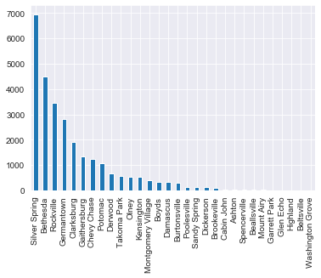Exploring the data showed that top 5 cities have over 70% of permits, with Silver Spring containing 25%.

Alterations and Construction account for about 81% of the data set.

The top 5 “Use Code”s contain 66% of the data.

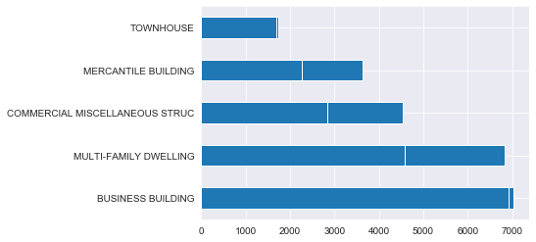Using the bucket variable of Value one can see that most of the permits fall into the range of 18-thousand-dollar to 200-thousand-dollar range. Using the similar variable of Area one can see that most permits range from 1 square foot to 5000 square feet.

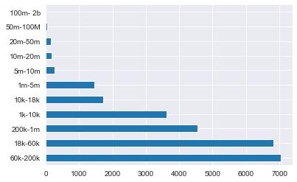 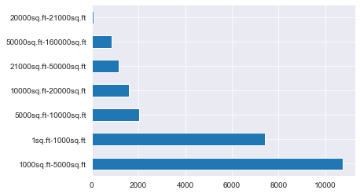

A large part of being able to discern what happed at a permits work site comes from the Description column. From this column, data was able to be extracted to show many things such as if a permit was a revision or was new work, like for instance the construction of a new house.

The first thing to be done in exploring the data was seeing how all the permits stacked up in terms of the buildings they occurred at. What was revealed was that over 41 percent of permits were either business building or Multifamily dwellings. Another thing gleamed from the investigation was that alterations consisted of more than 50% of the data followed by construction permits.

The next thing was check was how many permits were “doubles” meaning how many were on the same address and how many permits were issued for issued for the same job. Investigation of the description and address columns showed that 4193 of the address had at least two permits and that 3636 of the permits were revisions.

This exploring led to the next question of what the most permitted addresses in Montgomery County were. This turned out to be hospitals and malls. In the malls it was mostly just new mercantile business permit and by hospitals it was alterations and additions.

The next thing was to look at the status to see how many of the permits were open as open permits are a major nuisance for homeowners as stated in a Washington Post article:

“Permits are often an overlooked component of real estate transactions. So-called "open" permits can cause headaches for owners who are selling or financing their property. While title searches disclose encumbrances such as liens, mortgages, easements and restrictions, they do not disclose open permits, which must be independently searched at the local government.

When an owner obtains a permit to perform work on their property, the permit issued for that work is "open." Typically the work is completed, an inspection is performed by the local building department, and the permit is then "closed" by the local government. If this process is not followed, a permit search will disclose it.

There are several reasons why a permit may not be closed. An owner may obtain a permit, but not start or complete the work. Perhaps the work is completed, but the owner never asked the building department to perform an inspection. Perhaps an inspection is done, but deficiencies are noted that the owner does not correct, or that the owner does correct but fails to get re-inspected. (**Sandy Gadow, 2014)**”

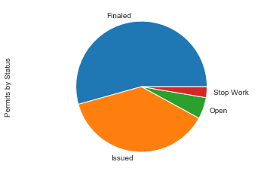In short, the idea was to see how many permits had a status of ‘opened’ and in which year were they most frequent.

So looking at the data one can see that the only 5% of the data is open permits and were mosly in recent years the and they fell in the normal way of the data set; meaning that they were mostly in alteration and construction. It was the same story with the use code. Finally further investigation showed that the open permits were evenly distributed across the County.

The next thing explored was the actul permits themselves. For example when they were issued and other similar things. First, based off of the data the hishest peak in the volume of permits bieng issued by the County is between May and July and that the days that the County was issuing them was mostly all days of the week except Friday and Staturday.

A big issue for any work site is how long a permit takes to be issued by the county. Therefor checking how long it takes a for permit to get issued is a very important statistic. The Department of Permitting Services Issue 79.4 days as the Average. So to check that all that had to be done is a simple matter of subtracting the issue date from the added date and inducing a new column from the result. The results from query showed that most of the years fell with in the 79.4 average. However there was a spike in the data in 2004 and 2011 so that was the next thing investigated in the report.

Looking at the spike in data the first thing was to find if there was anything relevant in the work type to wait time.

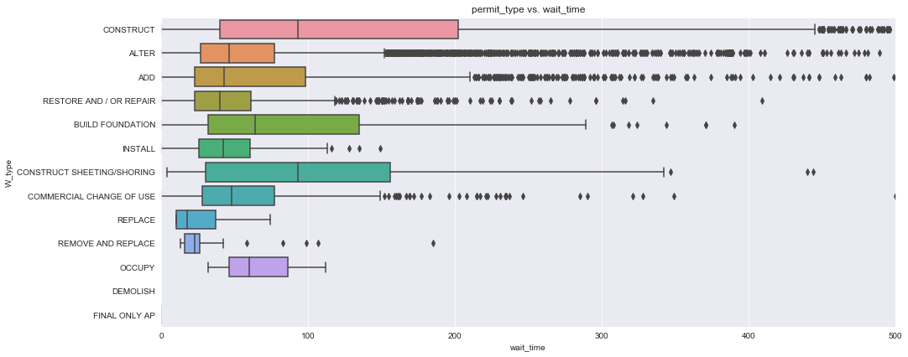

Looking at the result one sees that even though most of the permits were alterations still the clear victor was construction permits having an average of 100 and going to 200 days of waiting.

So, the next step was to see if there was any noticeable spike in the construction permits that correlated with the spike in the wait time figure.

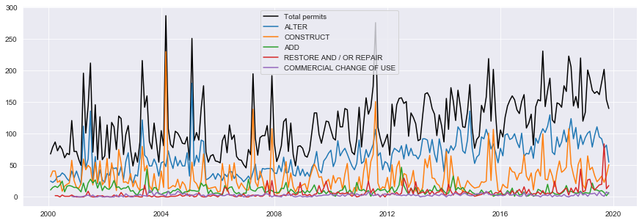

Looking at the data one can see that there is clearly a spike in construction in the years that there was a spike in the wait time. Further investigation of the data reveals that the spikes correlates specifically to Multi-Family Dwellings.

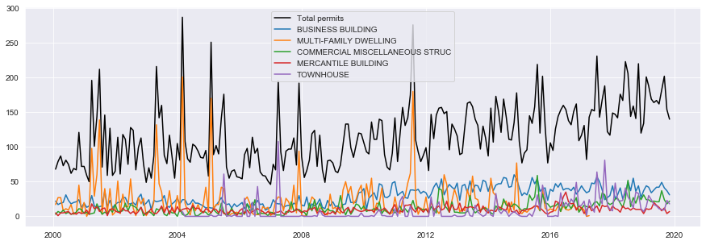

To clarify, not all work permitted that was done on multi-family dwellings was construction, but the work that took the longest to get issued was construction work in the multi-family dwellings.

The conclusion of the previous investigation of the data about the multi-family housing led to next investigation being about housing data. Housing a big concern as the Montgomery Trends states:

“The number of housing units in Montgomery County increased by 32 percent from 295,723 to 390,563 units between 1990 and 2016. This figure is lower than the 50 percent increase in housing supply in the Washington, D.C. region over the same period. Most of this growth took place in the 1990s and 2000s, with average annual growth rates exceeding 1 percent. In contrast, the average annual growth rate was only 0.7 percent from 2010 to 2016. Nearly one third of the growth in new units was in multifamily developments with 50-plus units. The total number of units in these types of buildings increased from 30,537 units to 60,458 units countywide between 1990 and 2016. (Source, Montgomery Trends) “

The Residential permit data set contained a little over 2000 instances of new houses being built.

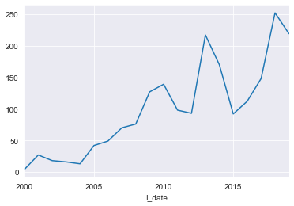 The trend here is although there is greater growth in multi family dwellings there is still growth. Even the housing bubble and the great recession didn’t slow growth and growth however minimal, is still happening.

The Residential Permit data set reveled other things that the commercial data set did not one thing was Solar Panel installation. Unlike the commercial data the residential permit has a decent amount of solar panel installations recorded. The data shows about 9500 installations total.

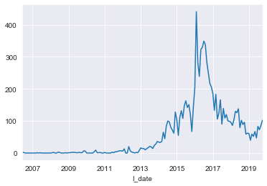

Further investigation shows that the vast majority of installations occur after 2015 then then crashed after 2016. This follows the national trend and almost certainly has to do with the tariff war with China and the lack of material as a result.

After seeing all the data and making observations and stories out of the data I have a newfound appreciation for permits. At a cursory glance all permits seem to be boring pieces of bureaucratic nonsense, but really, they are so much more than that. Within theses data sets lies the living history of the County and the trends that shape the daily lives of its citizens

References

DataMontgomery

Washington Post

County Trends